**PROJECT TITLE:**

**TO SUPPLY LEFTOVER FOOD TO POOR**

**College Name: Kamalam college of arts and science**

**College Code:** bru5s

**TEAM ID:**  NM2025TMID26812

**TEAM MEMBERS: 4**

**Team LeaderName:** MOHAMED IMTHIYAZ U

**Email:** **mohamedimthiyaz1581@gmail.com**

**Team Member:** **PANDIYAN D**

**Email:**  **pandipandi73030@gmail.com**

**Team Member: SANJAY R**

**Email:**  **sanjaysanjay56562@gmail.com**

**Team Member:** **MOHAN L**

**Email:**  mohan1812006**@gmail.com**

# 1.INTRODUCTION

## 1.1 Project Overview

## 

**Food waste is a global issue, yet millions go hungry every day. FOOD CONNECT aims to tackle this problem by:**

**Creating a digital platform using Salesforce for food donation logistics.**

**Connecting venues with surplus food to drop-off points via dedicated volunteers.**

**Streamlining task assignments and tracking execution details.**



[This Photo](https://belezaesaude.com/nutricao-saude-cerebro/) by Unknown Author is licensed under [CC BY-NC](https://creativecommons.org/licenses/by-nc/3.0/)

## 1.2 Purpose

# Supplying leftover food to the poor serves the dual purpose of combating hunger and reducing food waste. Organizations and initiatives in India, like the Indian Food Sharing Alliance (IFSA) and No Food Waste, coordinate the donation of surplus food from businesses and events to needy individuals through food banks, shelters, and community programs.

# DEVELOPMENT PHASE

**Creating Developer Account:**

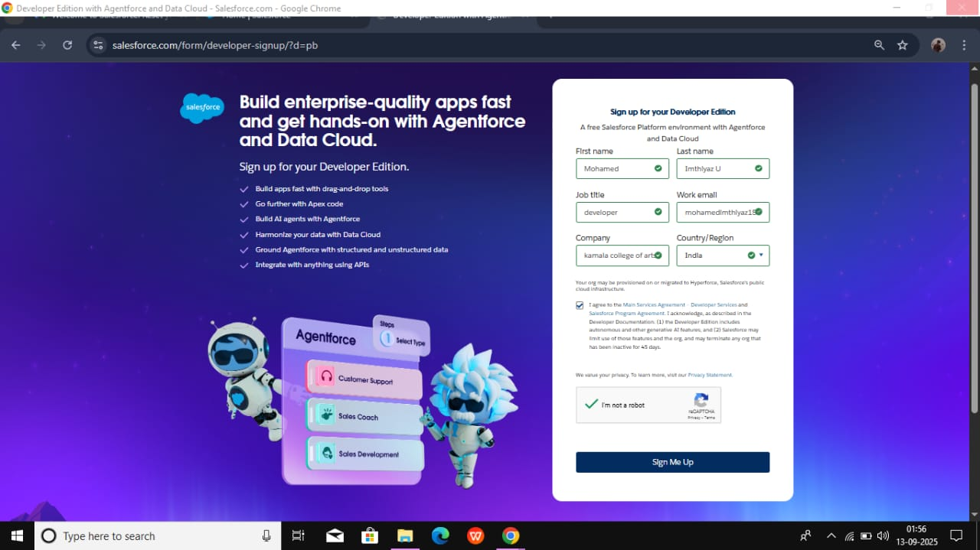

By using this URL[**- https://www.salesforce.com/form/developer-signup/?d=pb**](https://www.salesforce.com/form/developer-signup/?d=pb)

* Created objects: Venue,drop of point,volunteer,task,execution details

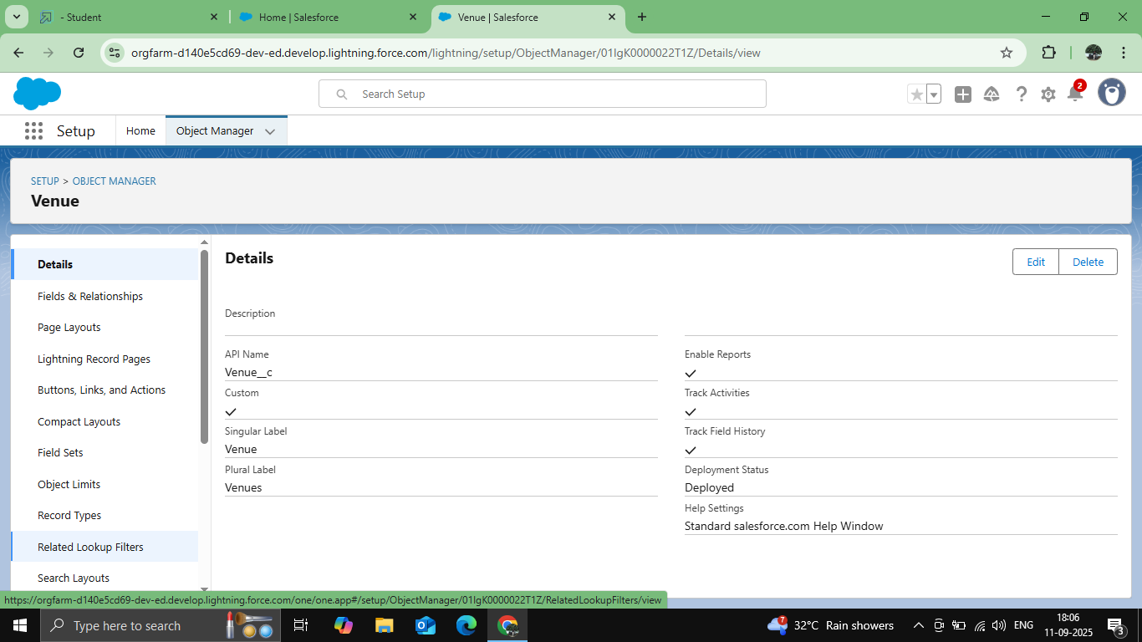

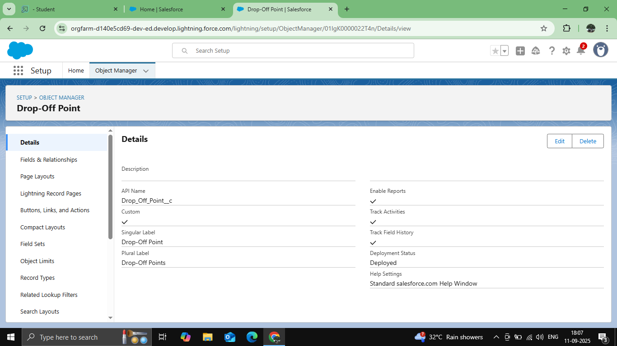

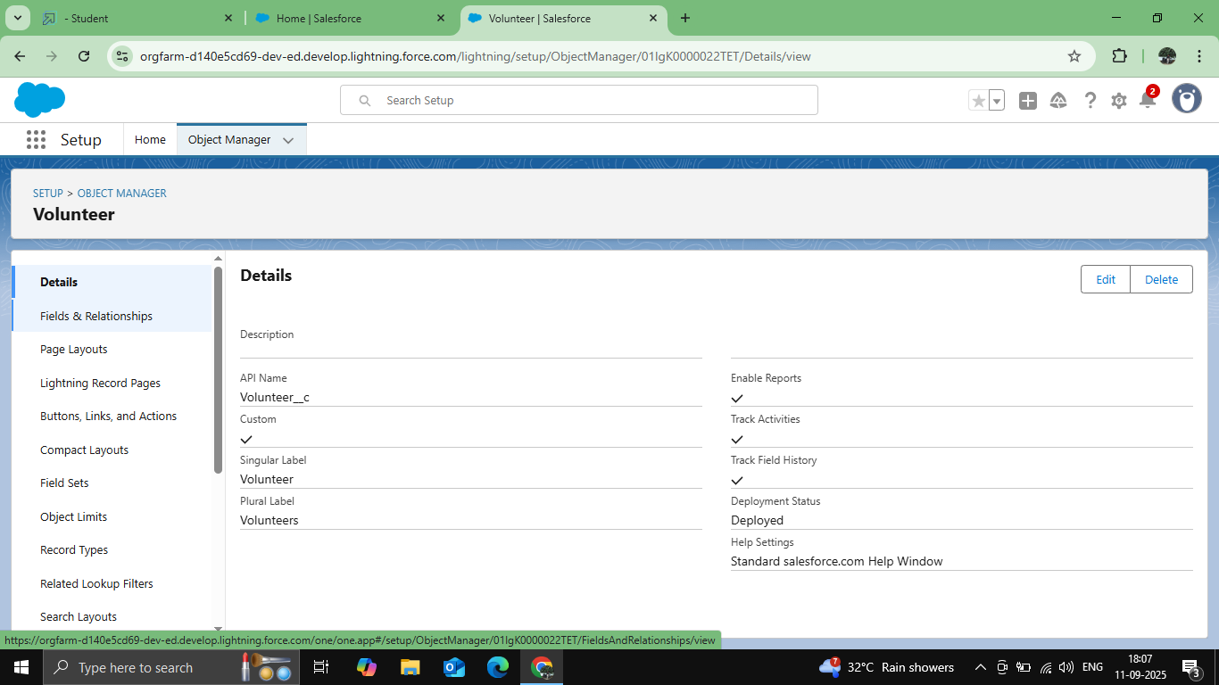

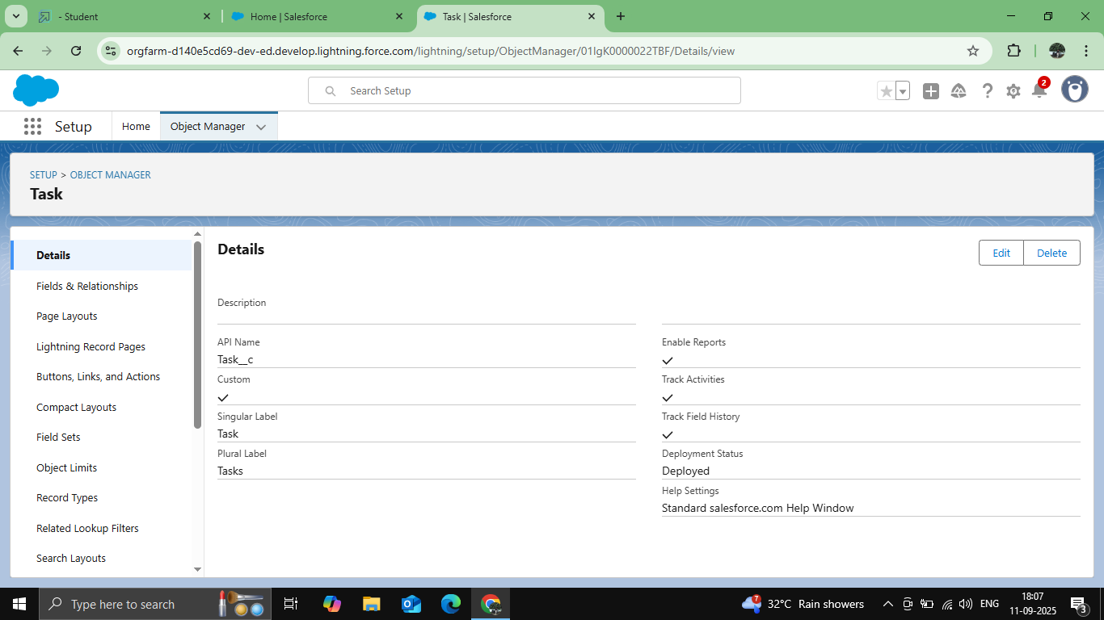

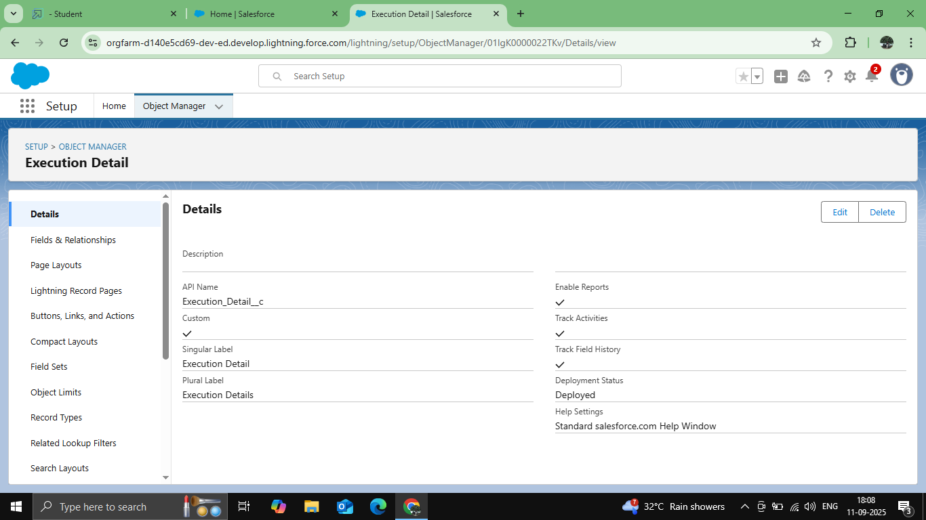

* Configured fields and relationships

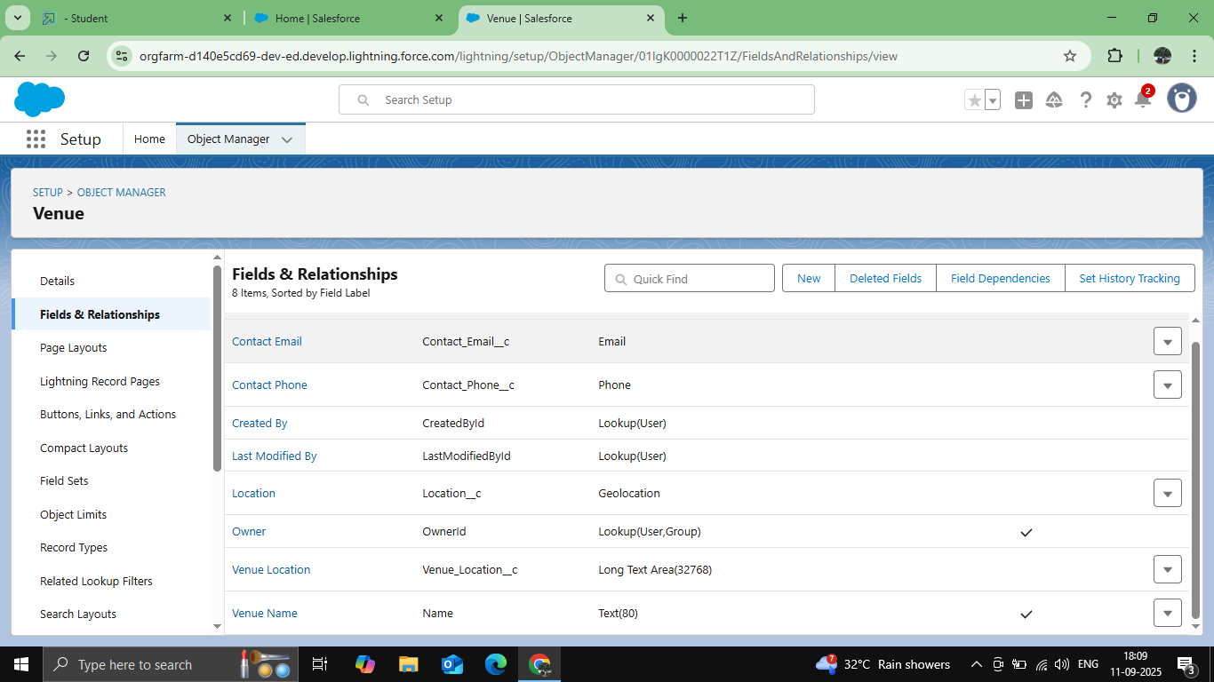

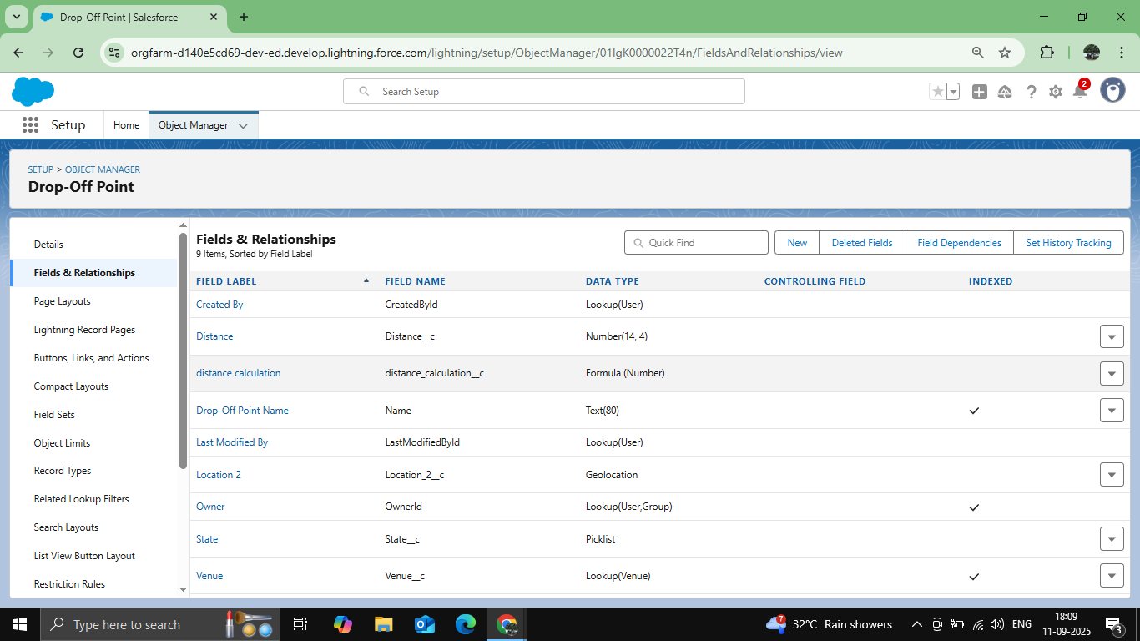

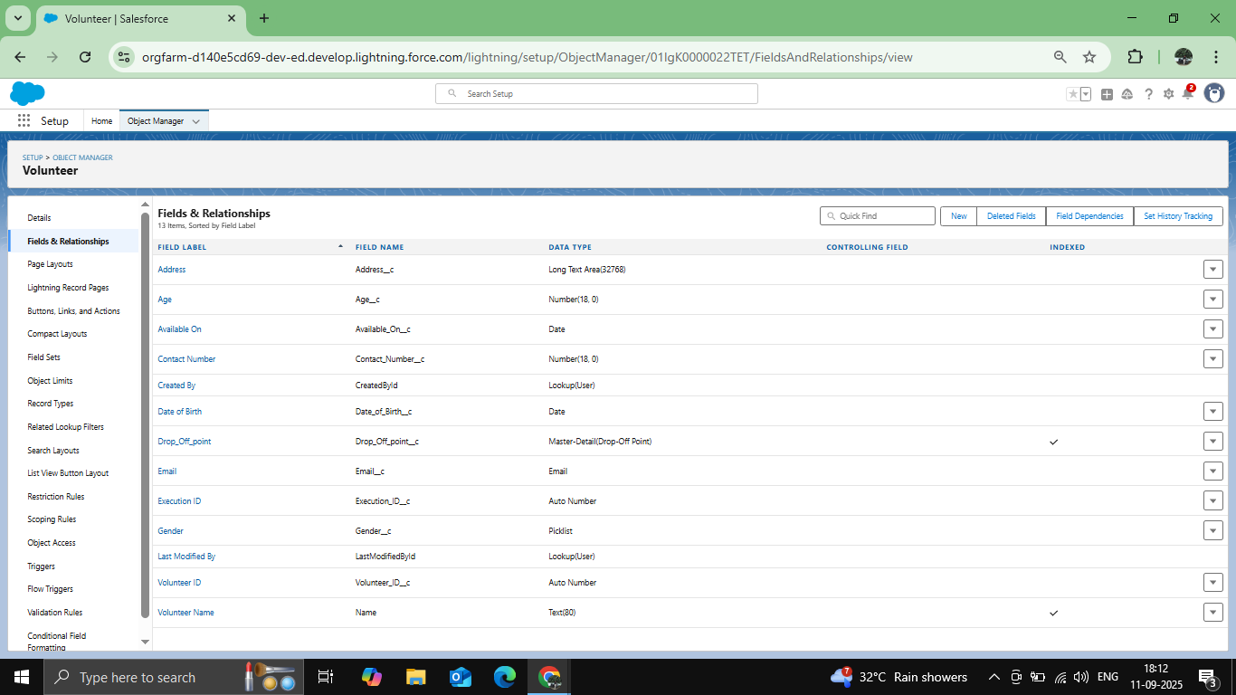

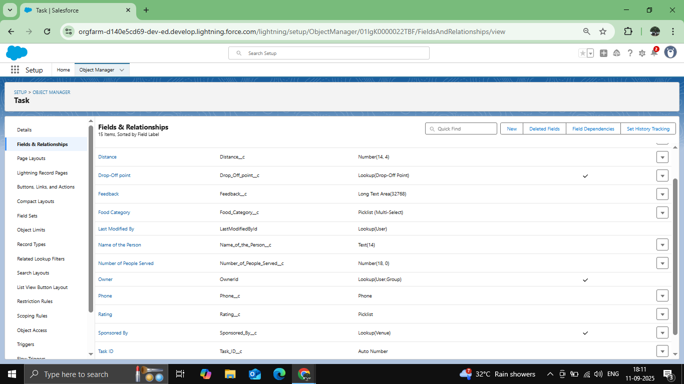

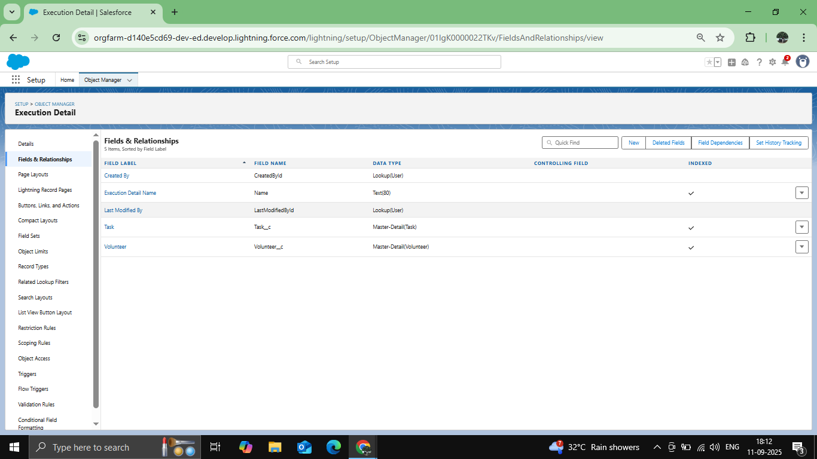

* Tabs

Steps to create custom tabs for easy navigation within the Salesforce app.

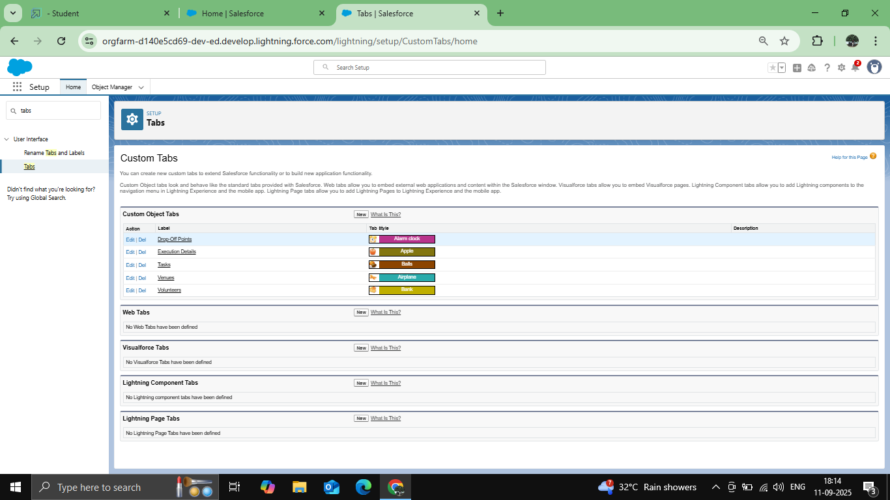

Developed Lightning App with relevant tabs

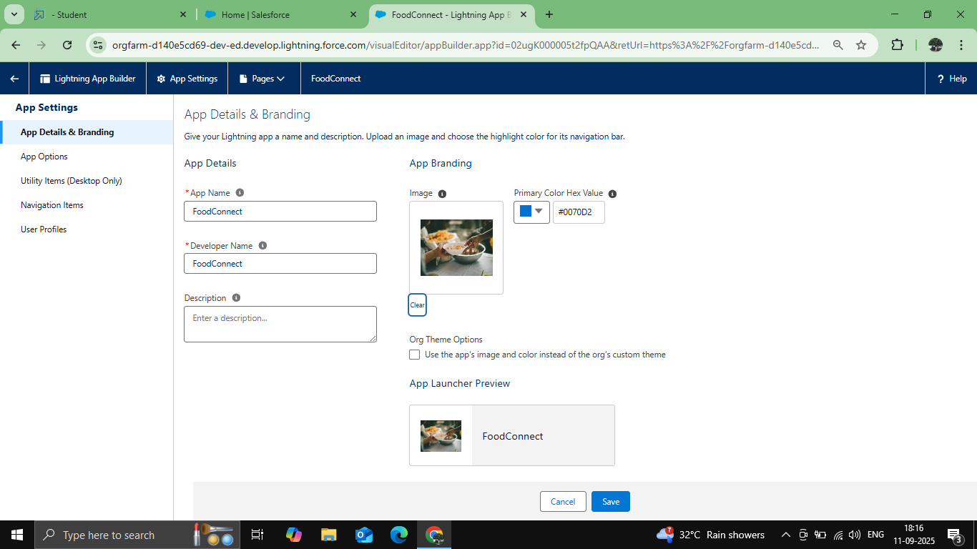

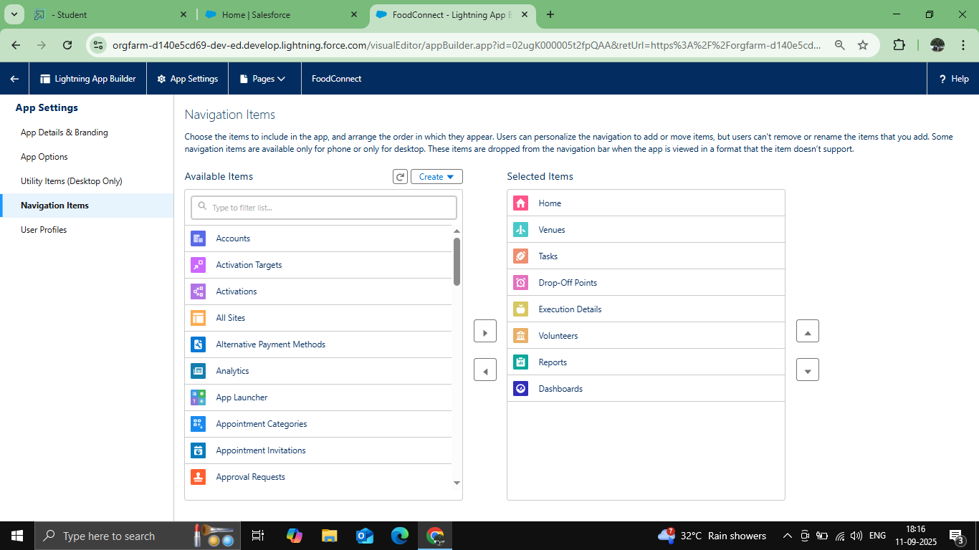

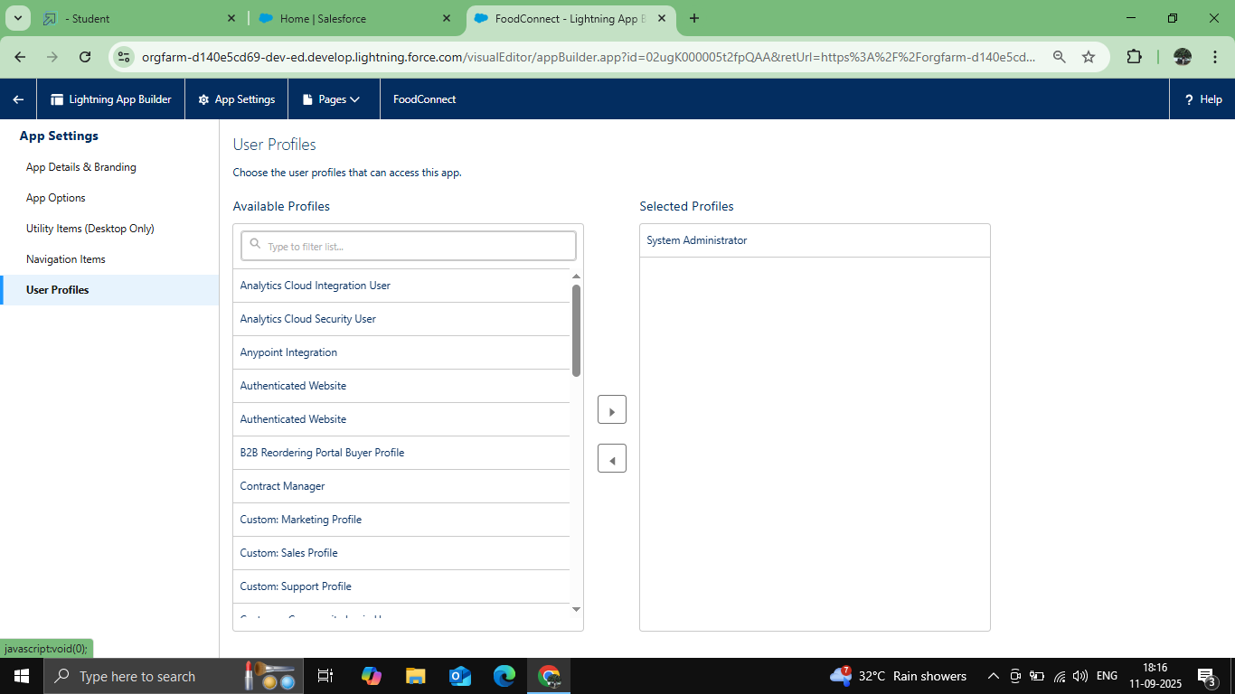

* Fields

Define custom fields and relationships for each object to ensure comprehensive data management

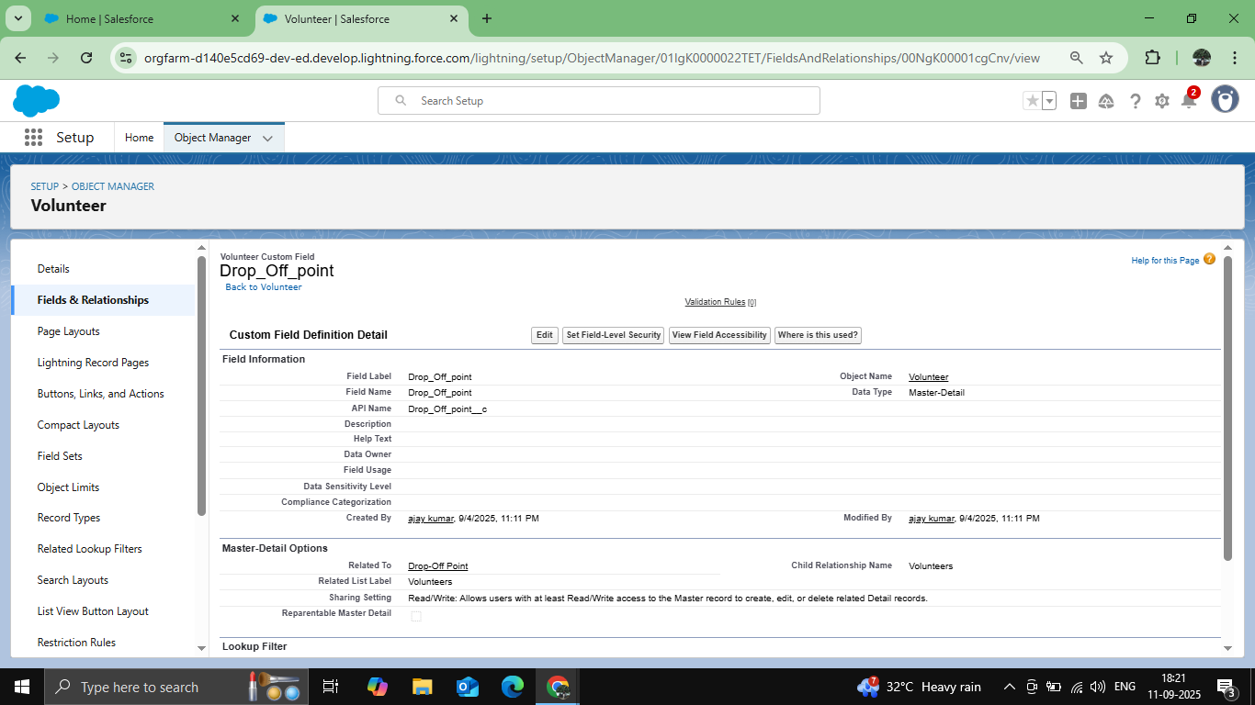

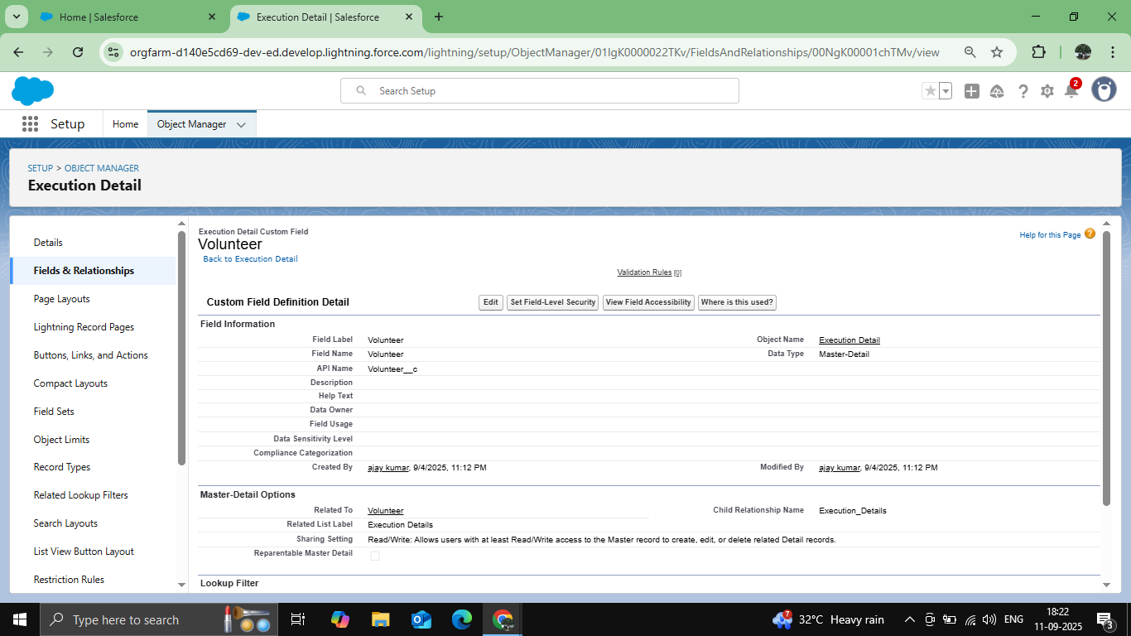

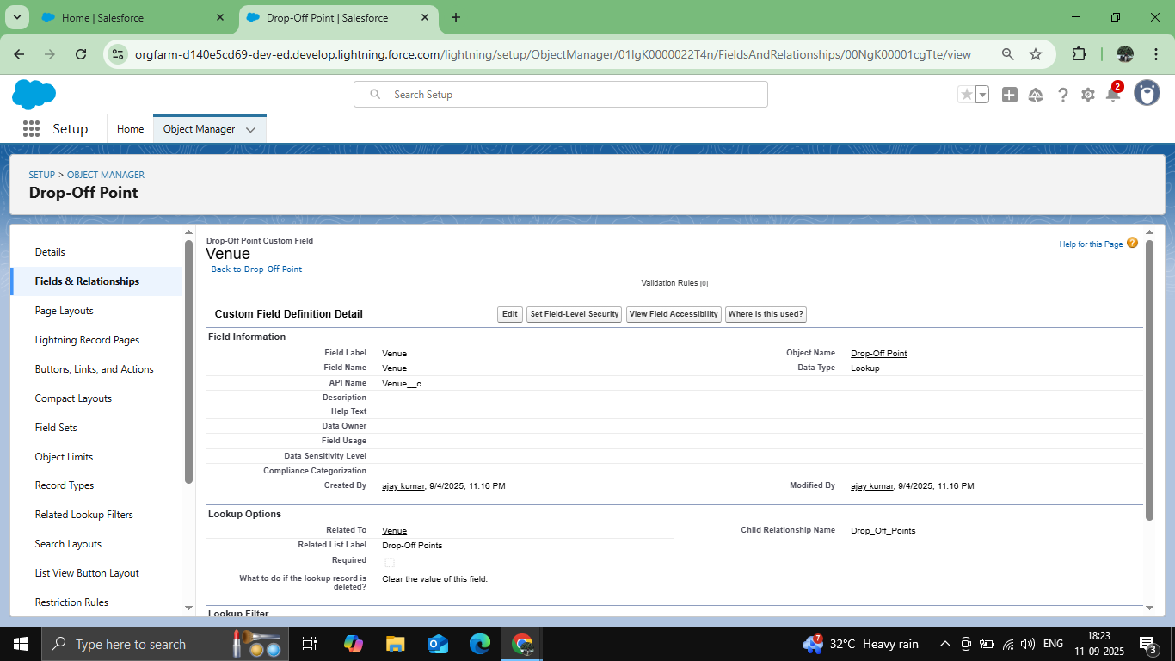

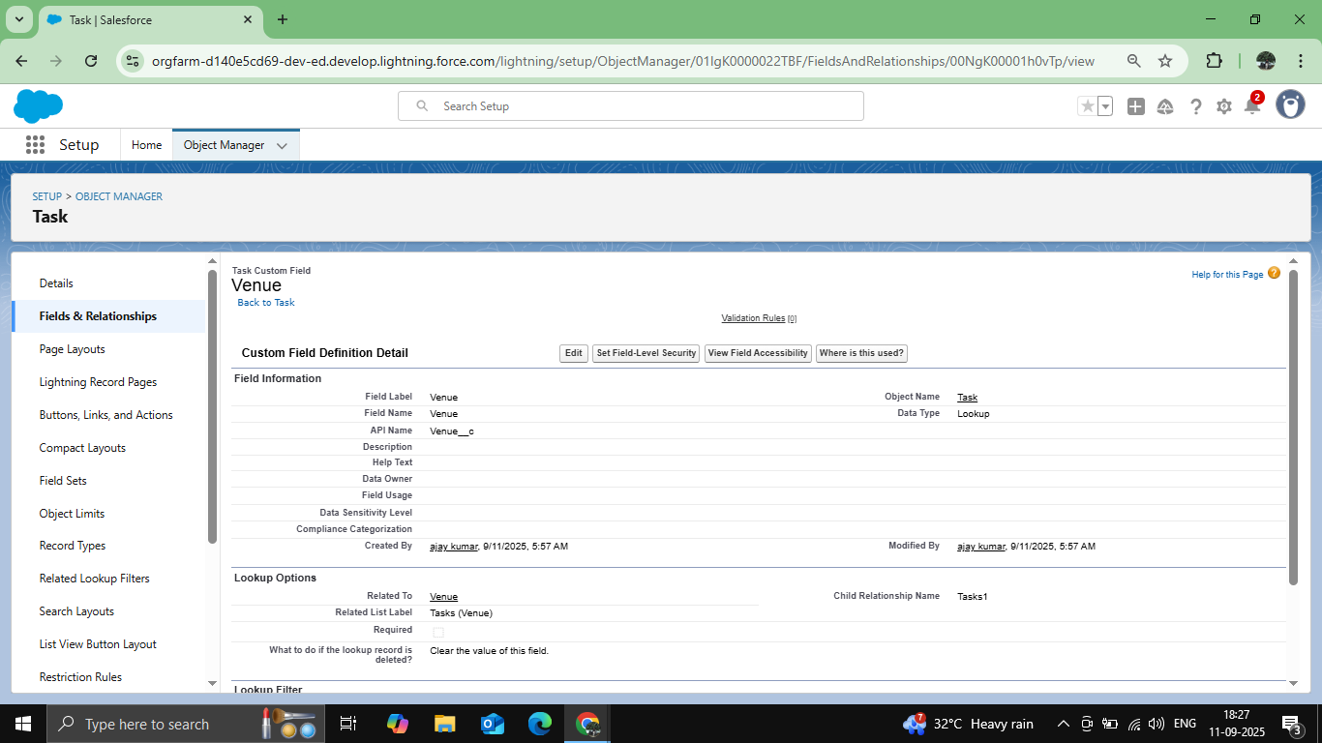

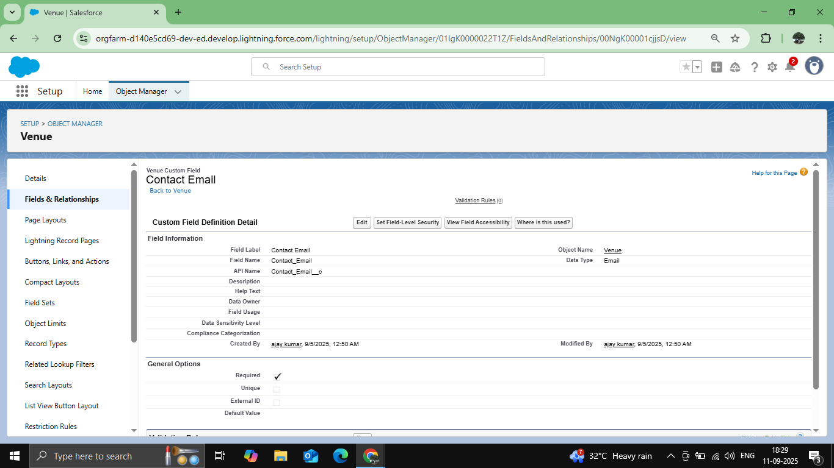

* Implemented Flows for monthly rent and payment success

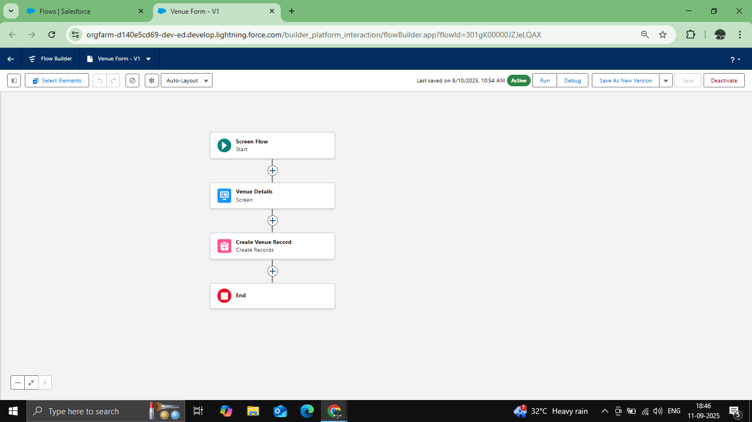

* Trigger

Automate actions with the DropOffTrigger.tgr file to handle event-driven logic.

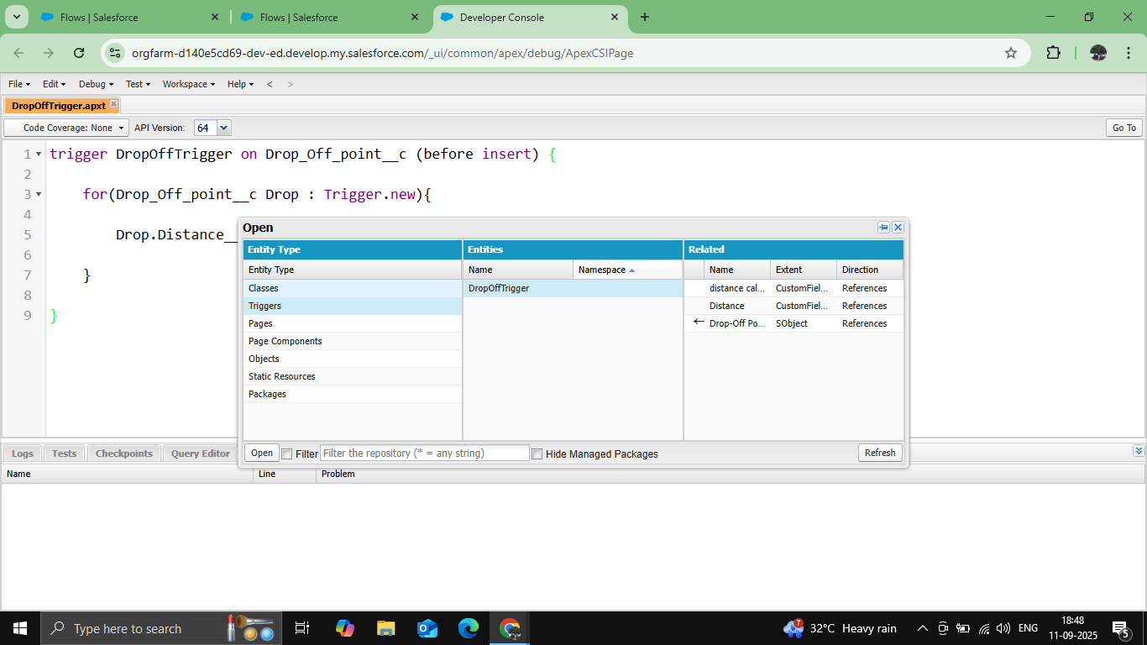

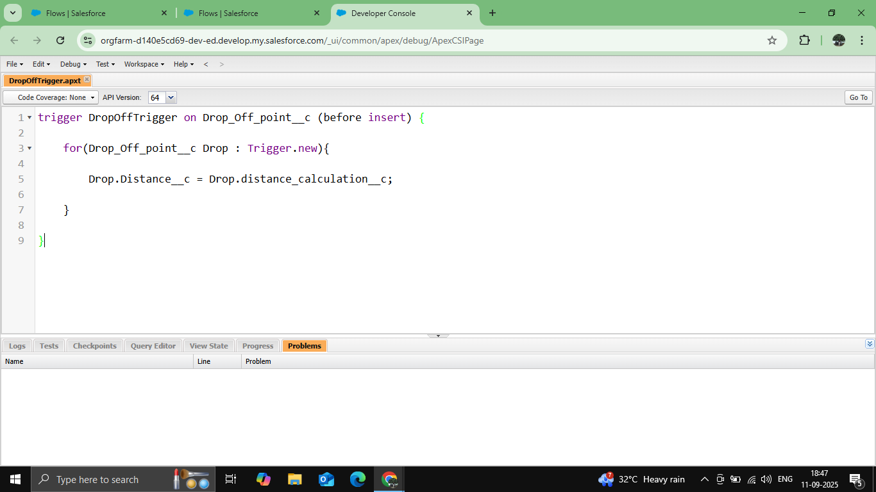

* Profiles & Permissions

Control user access and define permissions.

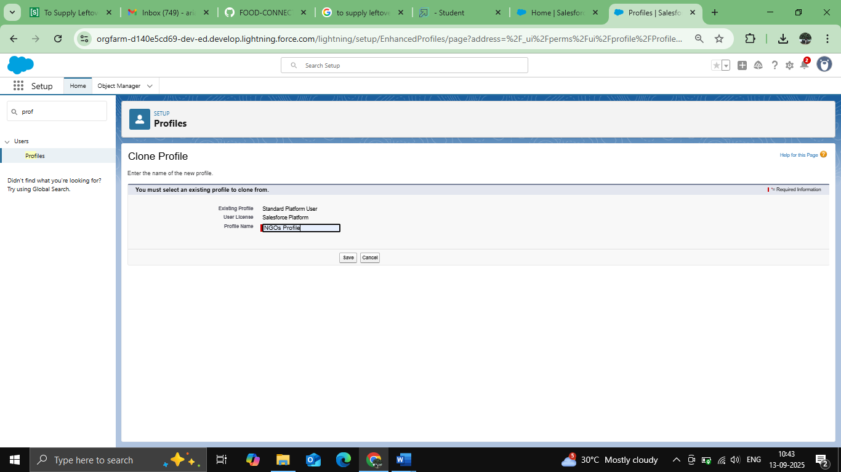

* User Creation

Guide to create users and assign roles effectively.

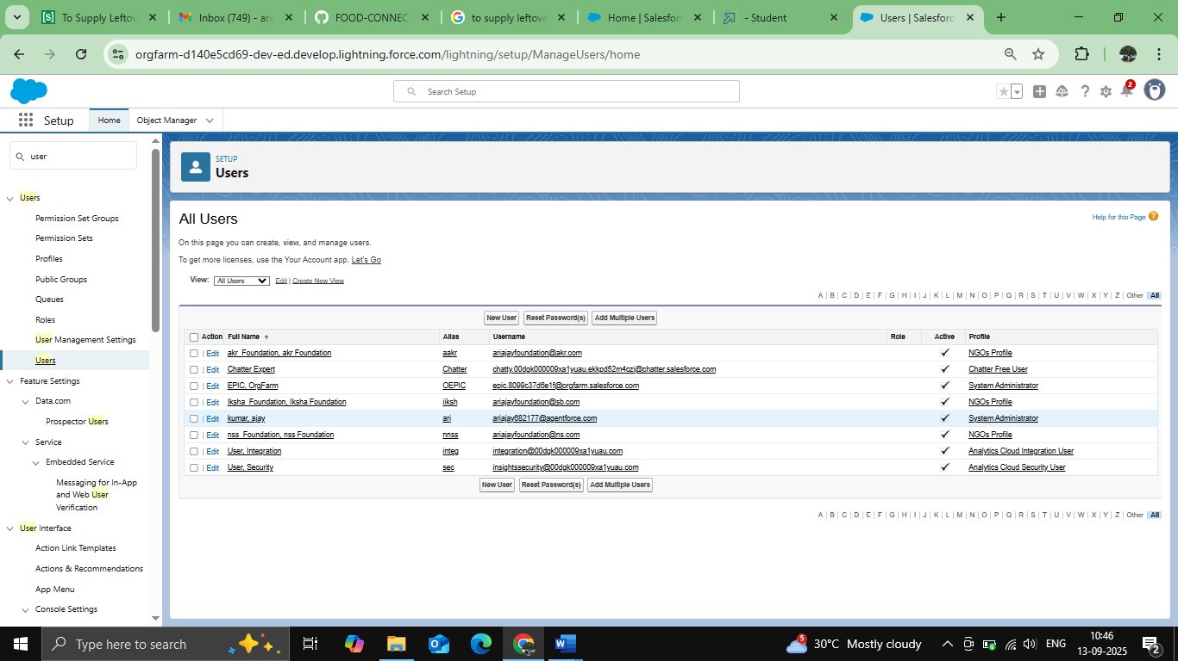

* Creation of public groups 1&2

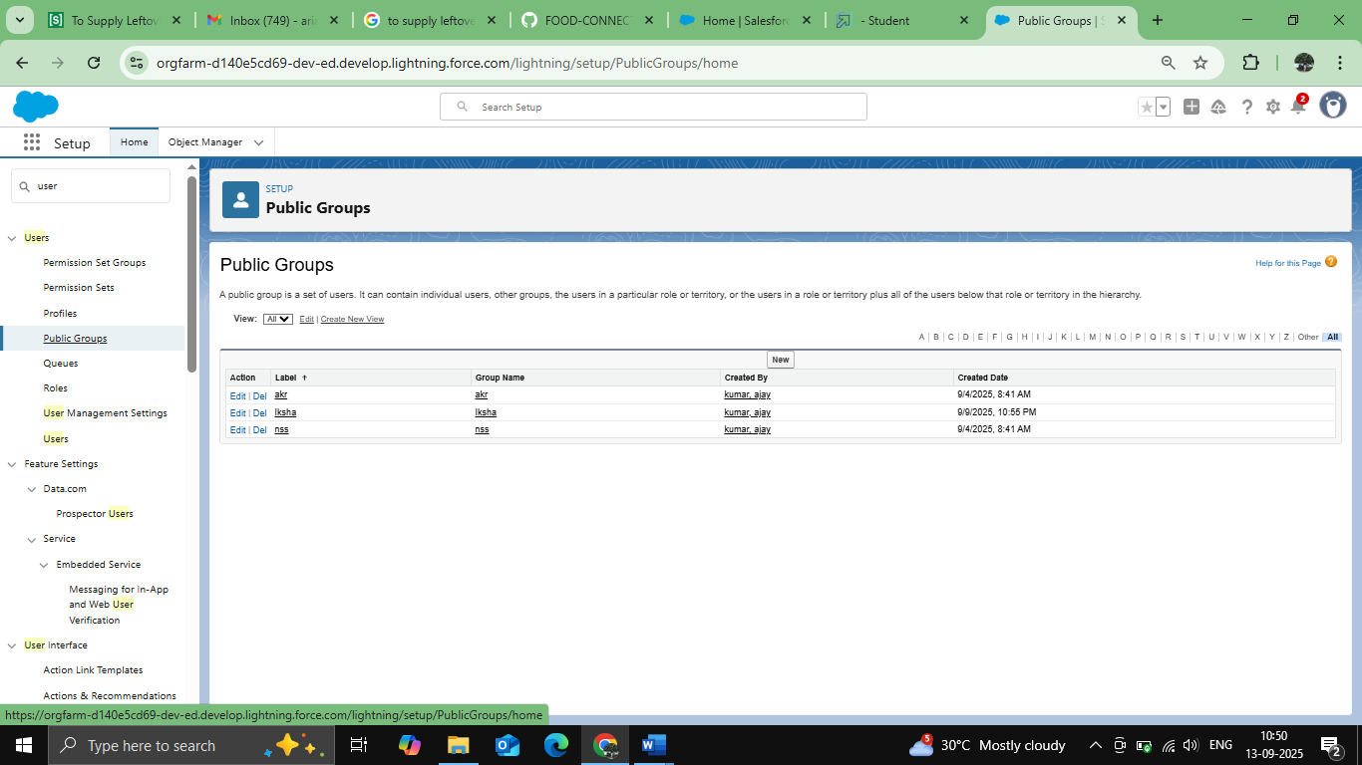

* Report Types

Organize public groups and generate dynamic reports.

Ready-to-use reports:

* Venue with Drop-Off and Volunteer

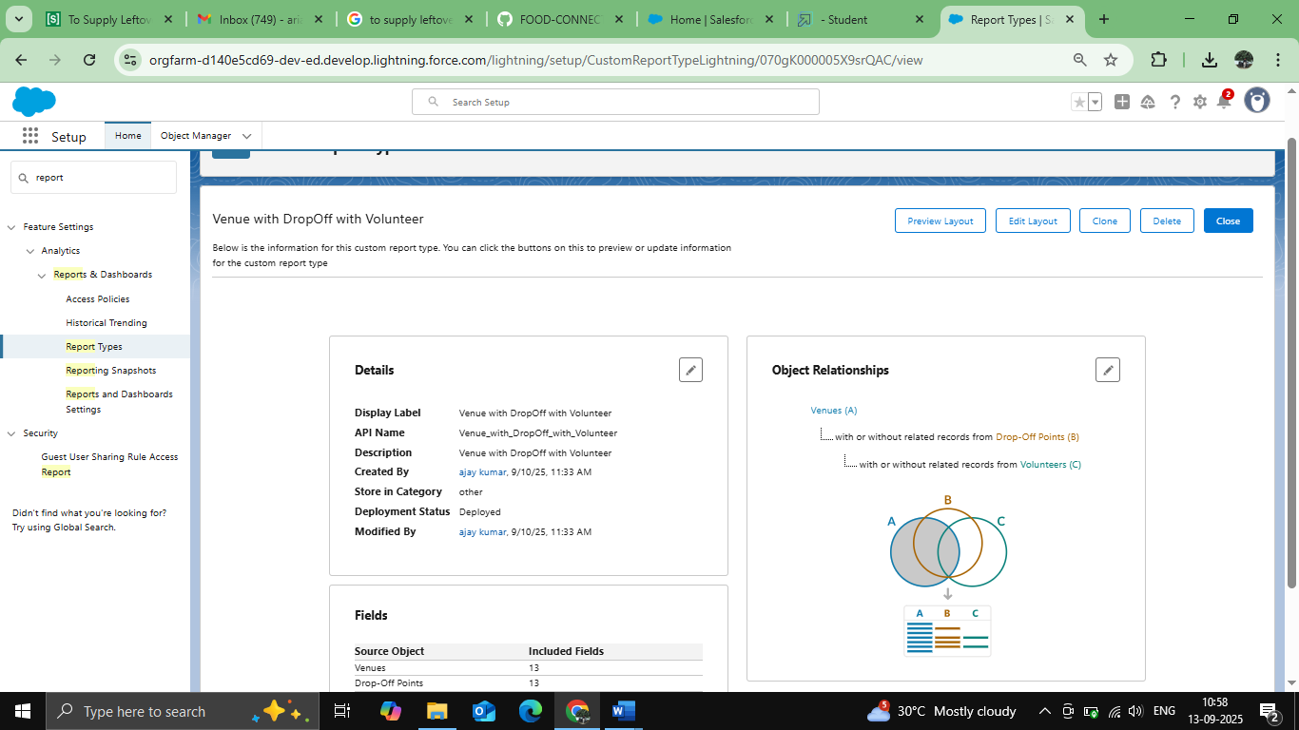

* Volunteers with Execution Details and Tasks

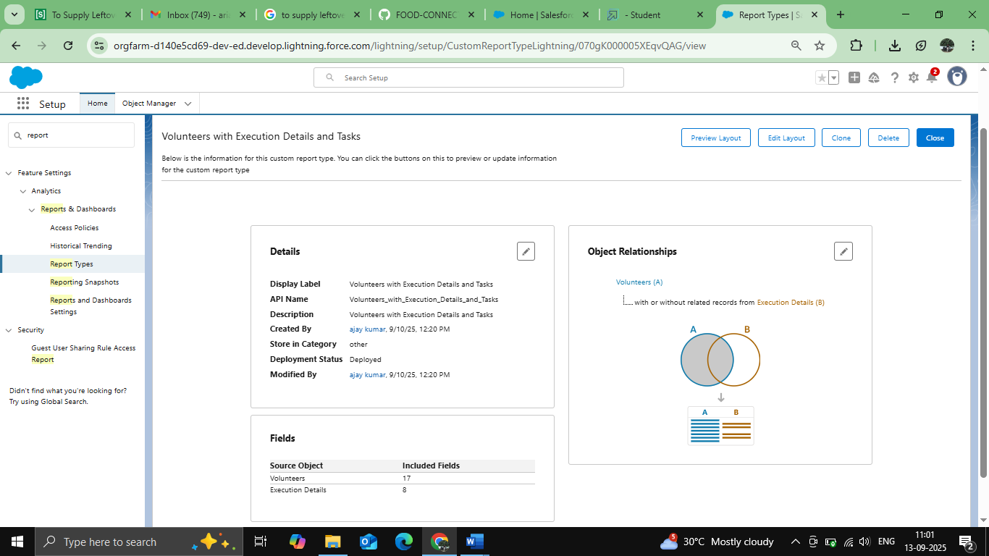

* Dashboard

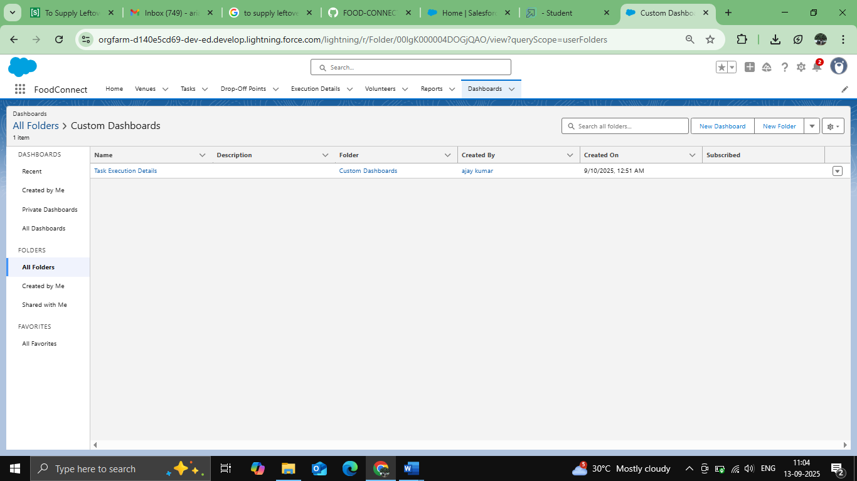

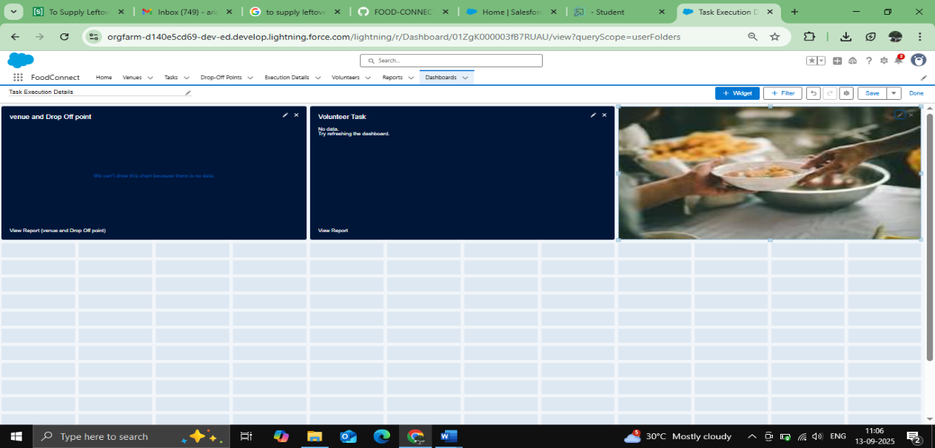

* Creation of Shareing rule

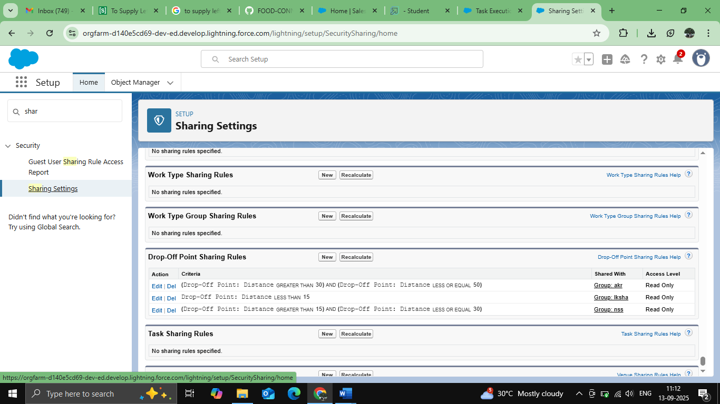

* Creation of home page

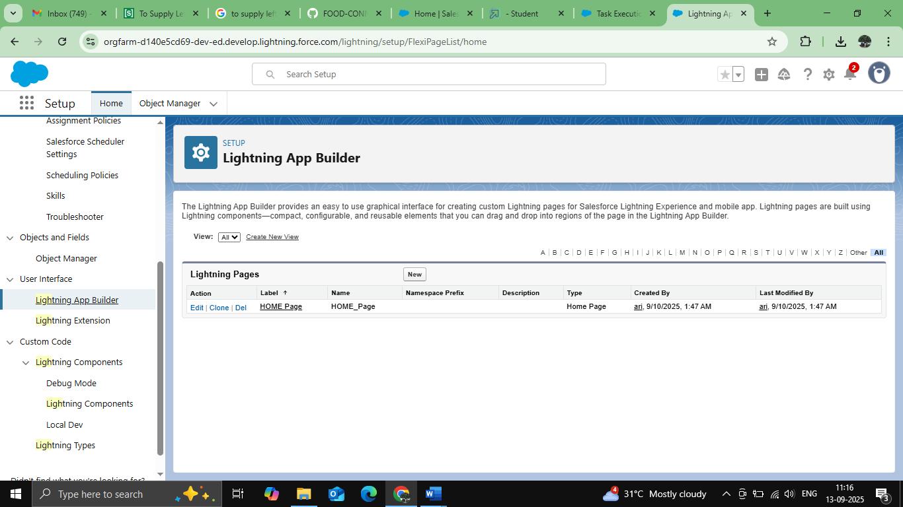

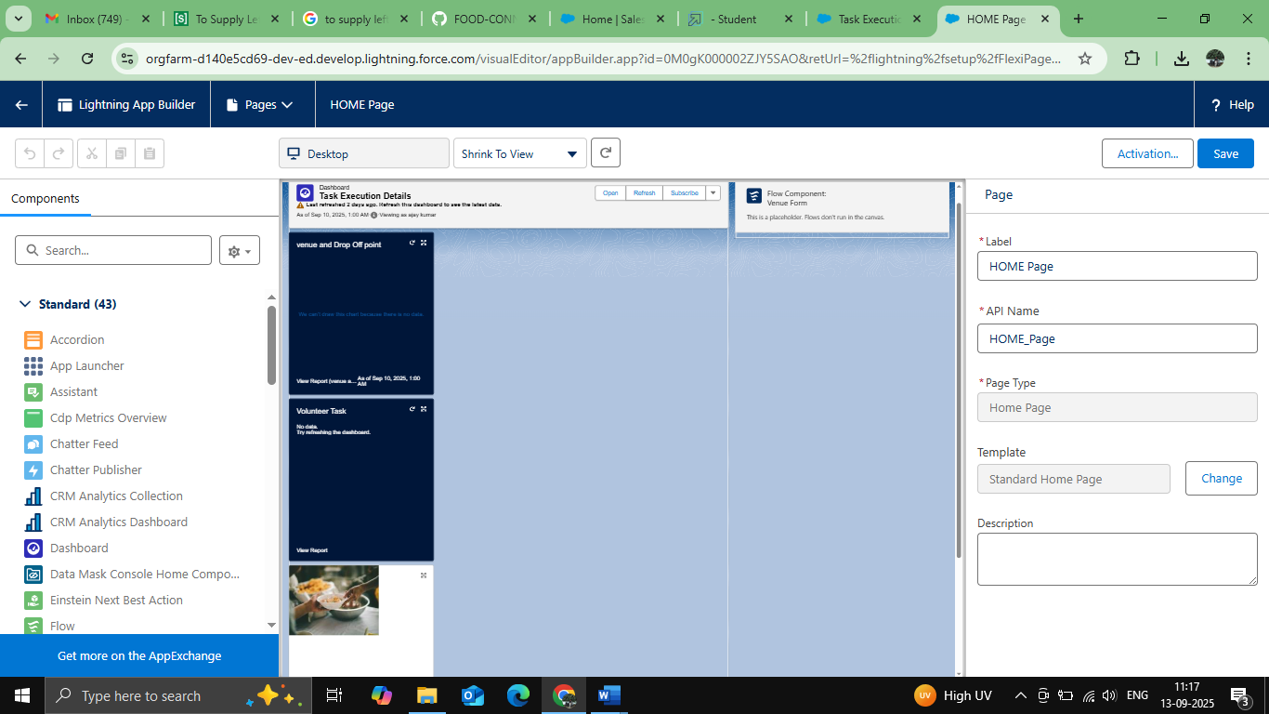

# CONCLUSION

Supplying leftover food to those in need is an effective and compassionate solution that addresses both food waste and hunger, fostering positive social, environmental, and economic impacts. While this approach offers many benefits, it is not a complete fix for systemic issues like food insecurity and requires coordinated effort to be successful.

## APPENDIX

● **Source Code:** Provided in Apex Triggers

trigger DropOffTrigger on Drop_Off_point__c (before insert) {

for(Drop_Off_point__c Drop : Trigger.new){

Drop.Distance__c = Drop.distance_calculation__c;

}

}